**Joint Query of Repairs table and Technician name from Technician Table:**

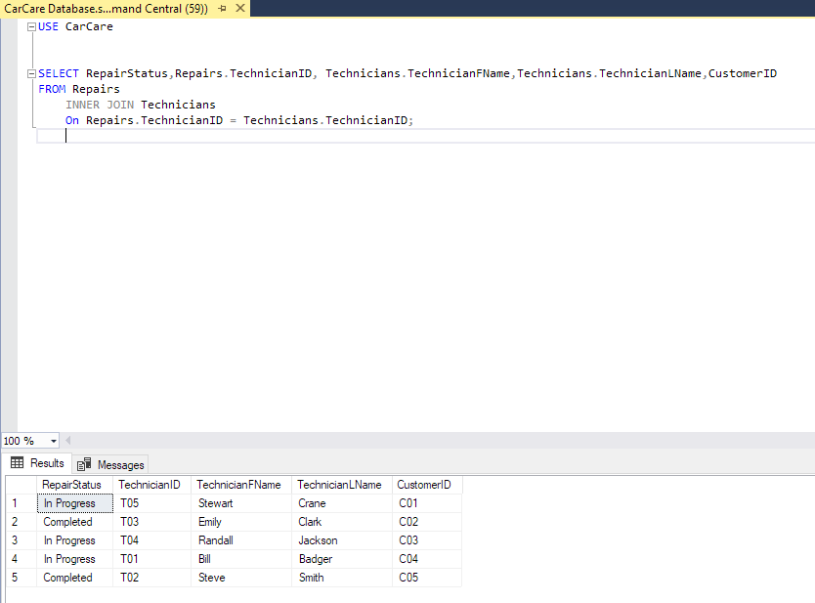

**Joint Query of Repairs table and Customer name from Customer Table:**

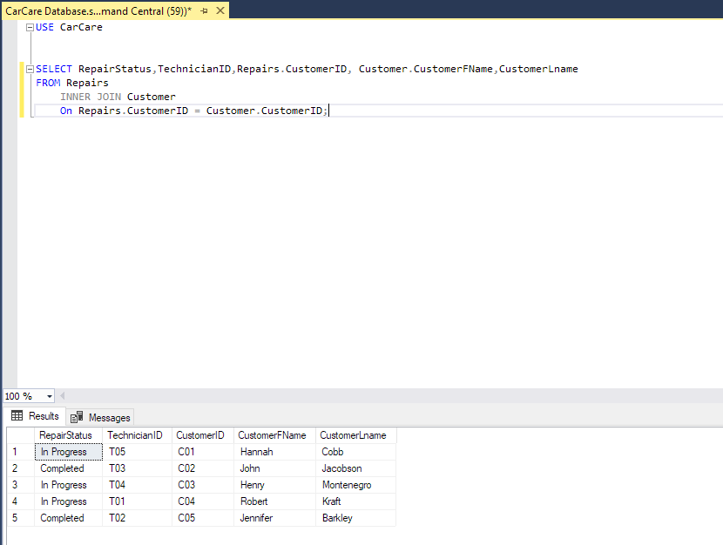

**All data from Administrators:**

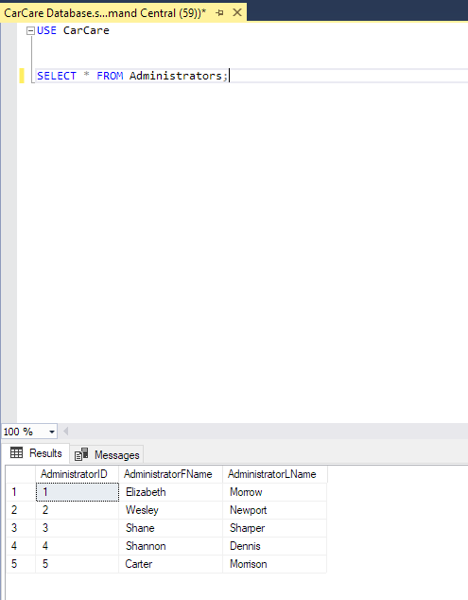

**Administrator Aggregate Query:**

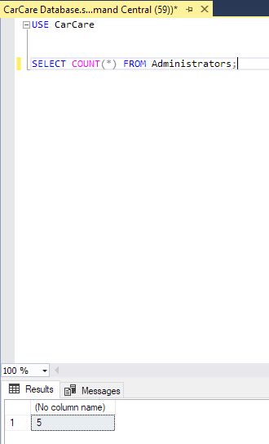

**CompleteRepairs All Data:**

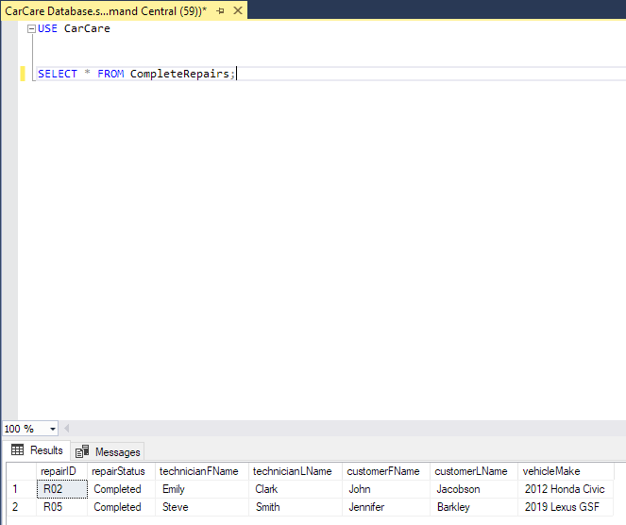

**CompleteRepairs Aggregate Query:**

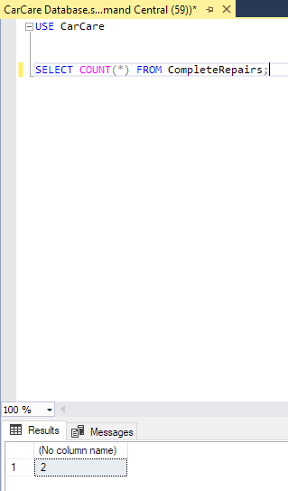

**Customer All Data:**

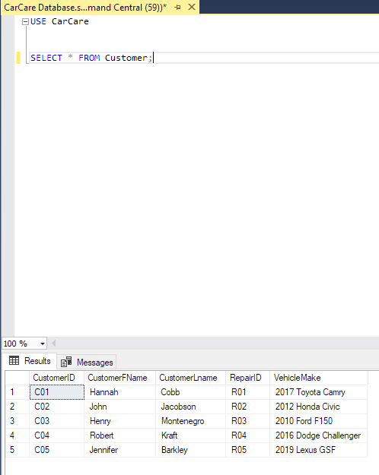

**Customer Aggregate:**

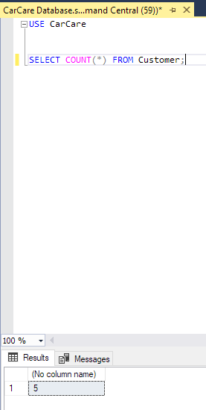

**InProgressRepairs All Data:**

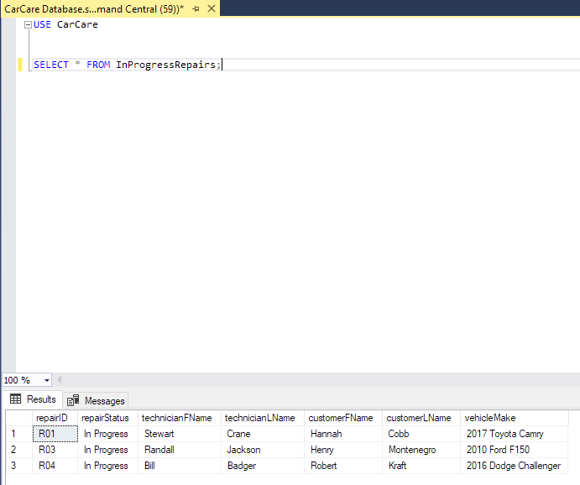

**InProgress Repairs Aggregate:**

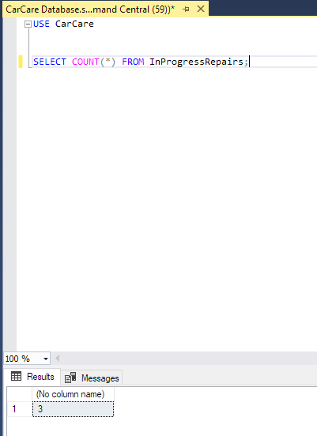

**Repairs All Data:**

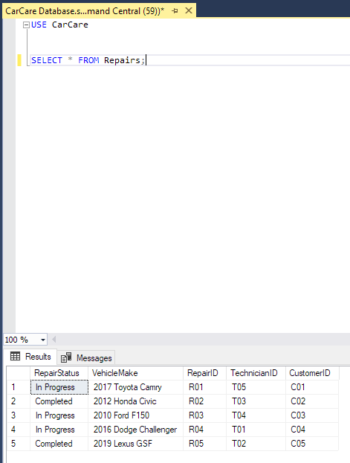

**Repairs Aggregate:**

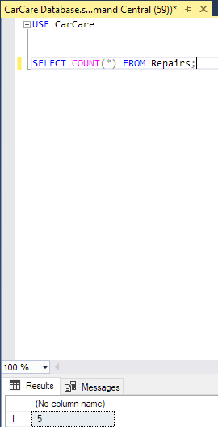

**Technicians All Data:**

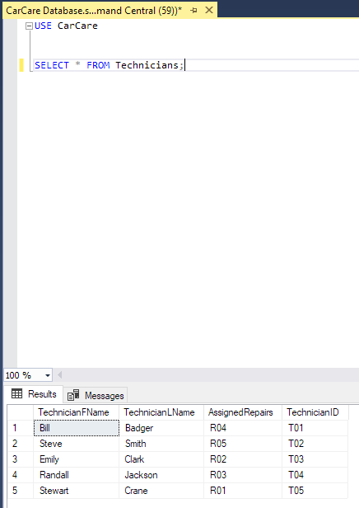

**Technicians Aggregate:**

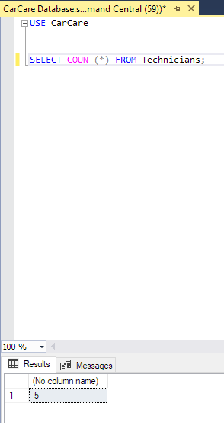

**Vehicles All Data:**

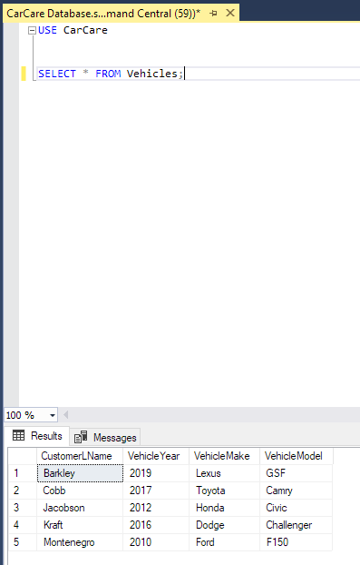

**Vehicles Aggregate:**

